Biology Department/NASA Space Radiation Laboratory
50 Bell Avenue, Building 463
Upton, New York 11973-5000
Telephone/Fax: (631) 344-7914/3407
Email: pwilson@bnl.gov

DATE: January, 2013

TO: Users of the NASA Space Radiation Laboratory (NSRL) or Tandem Van de Graaff
Radiobiology Laboratory

FROM: Paul Wilson, NSRL/Tandem Radiobiology Operations

SUBJECT: NSRL and Tandem Beam Information

This memo provides information regarding the ion species available at the NSRL and the Tandem Van de Graaff Radiobiology Laboratory during the calendar year 2013 campaigns, as well as NASA Space Radiation Program’s dose limits for NASA-funded experiments at NSRL. Ions available at NSRL in 2013 include (among others):

Ion Species | Energy  (MeV/n) | Max Intensity (ions/spill) | LET  (keV/µm in H₂O)
H-1 | 50–2500 | 6.4 x 10¹¹ | 1.26–0.21
He-4 | 200–1000 | 8.8 x 10⁹ | 1.80–0.89
C-12 | 135–1000 | 1.2 x 10¹⁰ | 21.21–8.01
O-16 | 100–1000 | 4.0 x 10⁹ | 47–14
Ne-20 | 300 | 1.0 x 10⁹ | 35.34
Si-28 | 94–1000 | 3.0 x 10⁹ | 151–44
Cl-35 | 500–1000 | 2.0 x 10⁹ | 80–64
Ti-48 | 150–1000 | 8.0 x 10⁸ | 265–108
Fe-56 | 100–1000 | 2.0 x 10⁹ | 494–150
Sequential Field (H/Fe) | 1000, 1000 | Varies | 0.21/150
Modeled SPE | 50–1000 | Varies | 1.26–0.21

The associated ranges of these ion species in water at energies of 100–1000 MeV/n are plotted against their respective LET values below:
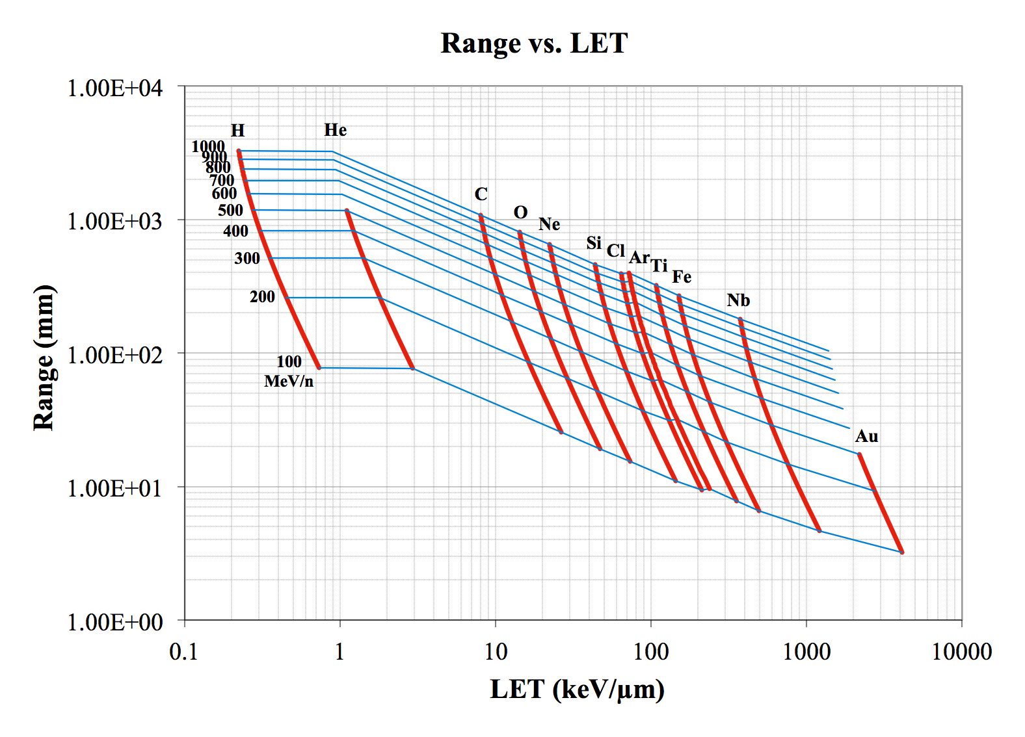

Dose rates range of several Gy/min down to ~100 particles/cm² per spill are available for the majority of these ion species when using the standard 20 cm x 20 cm beam spot (consult NSRL physics/dosimetry team for specific details). Proton dose rates are typically limited to less than 1 Gy/min. Note that experimental Bragg curves may be produced at the NSRL for any ion/energy combinations with ranges ≤46 cm upon request.

In 2013, the NSRL will again offer the 60 cm x 60 cm large exposure field (LEF) or “big beam” configuration. Users are encouraged to take advantage of this large exposure area (nine-fold larger than the standard 20 cm x 20 cm beam spot), and several days per campaign may be reserved for use of the big beam configuration, depending on user demand. Users interested in using the big beam configuration (e.g., for SPE simulations) should contact the NSRL operations team for scheduling. Note that dose rates for the big beam configuration are lower than those available for the standard 20 cm x 20 cm beam spot (typically 0.5 Gy/min maximum).

NASA has instituted new dose limits for NASA-funded experiments performed at the NSRL (note these dose limits do not apply for non-NASA-funded user teams that purchase their own NSRL beam time). These dose rules are as follows:
- For experiments using Z=1 and Z=2 ions (protons and helium), only two (2) doses greater than 0.5 Gy (50 cGy) will be allowed. For example, a user may propose doses of 0.5, 1, and 2 Gy, but not 1, 2, and 5 Gy.
- For experiments using Z>2 ions (e.g., carbon), only one dose above 0.5 Gy will be allowed. For example, a user may propose doses of 0.1, 0.5, and 2 Gy, but not 0.1, 1 and 2 Gy.
The scientific rationale for these new dose limits is based upon a potential total GCR HZE dose on a Mars mission of 0.2 Gy at solar minimum behind shielding. Total proton and helium doses could also be about 0.2 Gy, but could be significantly higher (≥1 Gy) during solar particle events (SPEs). Rationale for requesting additional higher doses for NASA-funded studies include:
- To complete the determination of radiation dose-response curves that already include lower doses, including studies where saturation of biological responses may occur.
- Completion of experiments using higher doses that were initiated in previous NSRL campaigns.
- Collection of comparative data sets for specific comparison with existing human radiation epidemiology or radiation oncology data sets.
- Exploratory studies of new radiobiological effects where dose regimes have not been determined.
- Appropriate studies of radiation effects on biomolecules that require higher doses for proper assay sensitivity.

Ions available, with their associated LET values and ranges in water, at the Tandem Van de Graaff Radiobiology Laboratory in 2013:

Ion Species | Max. Energy  (MeV/n) | LET  (keV/µm in H₂O) | Range in H₂O (µm)
H-1 | 28.8 | 2 | 8060
Li-7 | 9.6 | 50 | 657
Be-9 | 8.0 | 94 | 440
B-11 | 7.9 | 147 | 348
C-12 | 8.2 | 204 | 291
O-16 | 6.9 | 400 | 179
Si-28 | 5.3 | 1210 | 91
Fe-56 | 3.6 | 3730 | 55
Ge-73 | 2.6 | 5400 | 44
Ag-108 | 1.7 | 8250 | 35
Au-197 | 0.8 | 11400 | 30

The Tandem Van de Graaff Radiobiology Laboratory beamline currently has a beam spot diameter of 1.05 cm (0.87 cm²) and can accept standard P-35 tissue culture dishes or multi-well microscope chamber slides. The P-35 dishes may be placed either vertically or horizontally (i.e., perpendicular or parallel to the beam, respectively) depending upon experimental needs; microscope chamber slides can only be placed vertically (perpendicular to the beam). Individual wells of multi-well microscope chamber slides may be targeted for exposure using a custom translation stage and computerized controller, without requiring user access to the interlocked irradiation chamber until all irradiations are complete. Special considerations must be taken when designing Tandem irradiation experiments due to the limited ranges and significant air/plastic attenuation of these lower energy ions. Examples of these culture dishes and holders are shown below (the P-35 dishes shown below are custom dishes with either center bore cutouts or wall cutouts for subsequent coverslip-based cell staining and imaging):
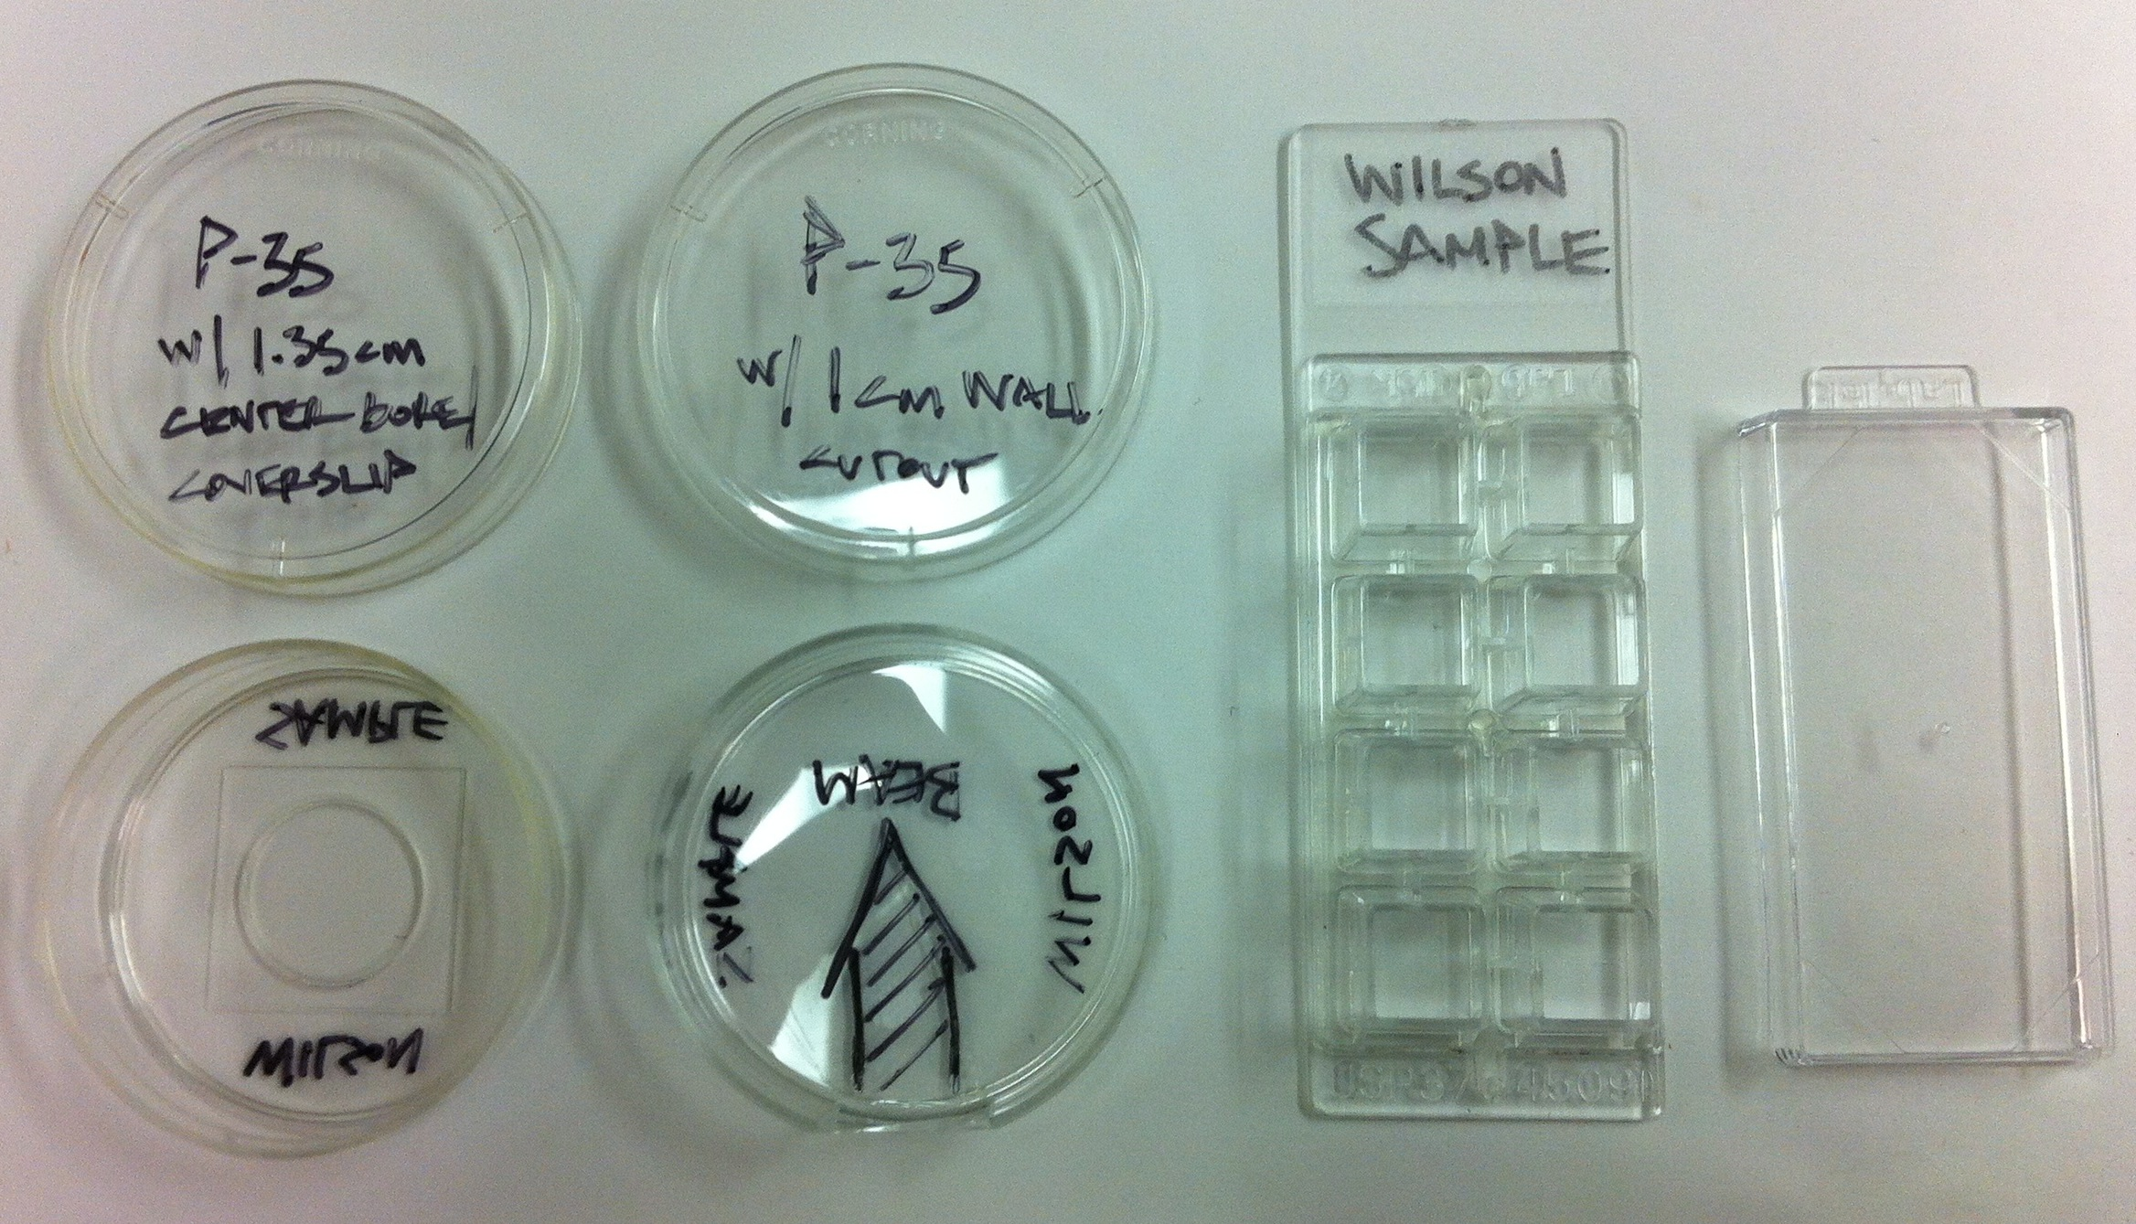

Examples of P-35 tissue culture dishes and multi-well microscope chamber slides that
can be placed in the Tandem Van de Graaff Radiobiology Laboratory irradiation chamber.

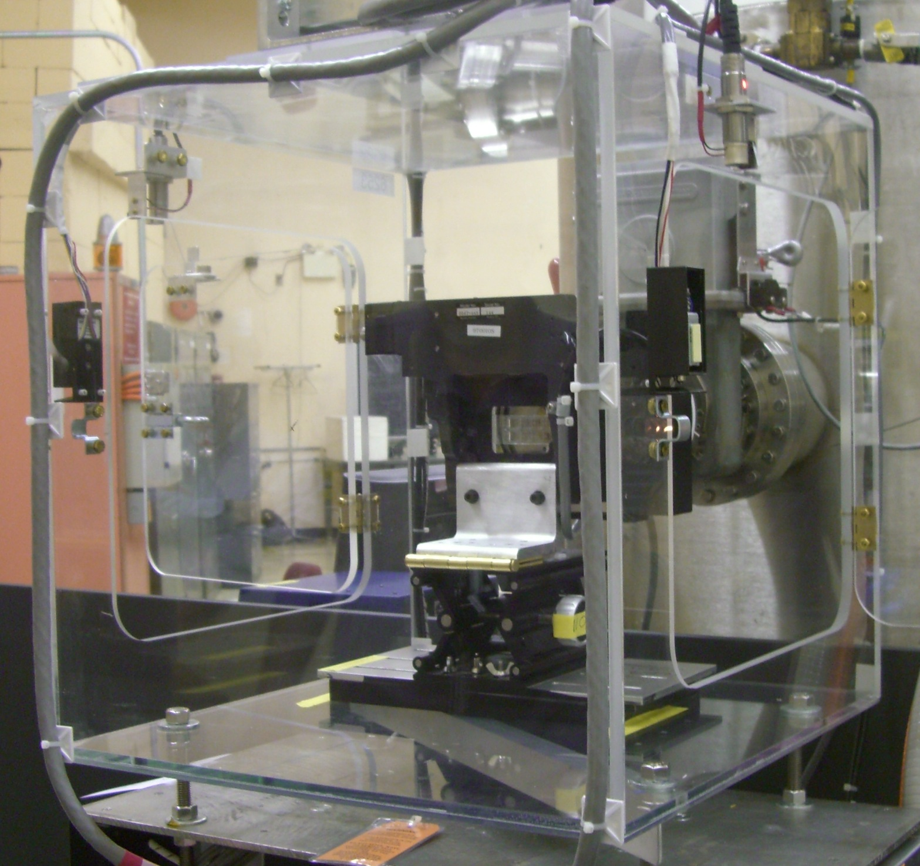
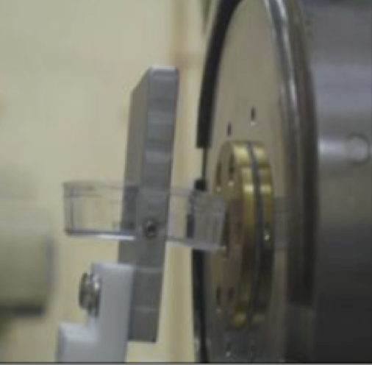

(Left panel) Horizontal P-35 dish holder positioned (parallel to beam) at the Tandem beam window.
(Right panel) The microscope multi-well chamber slide translation stage system in the Tandem
irradiation chamber. Once the chamber is interlocked, specific wells are positioned relative to
the beam window under computer control and verified with a downstream positioning camera.

